China, With Methodical Discipline, Conjures a Market for Electric Cars

Nearly half of all plug-in vehicles are sold in China, driven by relentless subsidies and regulations

Electric Cars Are a Hit With Chinese Consumers
China is the world's largest market for electric vehicles, thanks largely to a relentless program of subsidies and incentives. Photo/Video: Eva Tam/The Wall Street ​Journal​
By
Trefor Moss
Oct. 2, 2017 10:24 a.m. ET
243 COMMENTS
SHANGHAI—China has created the world’s largest electric-car market by sheer force of will, a giant bet on domestic production that’s leaving major foreign auto makers scrambling to keep up.
The government is funding its own manufacturers, luring domestic buyers with subsidies and building a vast charging-station network—while strong-arming its consumers by making sure buying an electric car is the only sure way to get license plates in crowded cities.
William Zhou, a 33-year-old software-company manager, recently abandoned his 18-month quest to buy a gasoline-powered foreign car—a middle-class status symbol—when his wife became pregnant.
He drives in gridlocked Shanghai, where severe restrictions on issuing license plates for new gas-powered cars don’t apply to electric or plug-in hybrid models. He settled for a Chinese plug-in hybrid because “I didn’t want to waste any more time and energy on the license plate.”
In the U.S. and elsewhere, there is some skepticism about whether electric vehicles will be a significant market soon. China has made up its mind. One goal is to curb pollution and reduce reliance on foreign oil. China’s chief aim, though, is to use the emerging electric market to improve the patchy quality of its domestic auto makers. To that end, it is using industrial-policy measures to create a giant test bed for its companies’ designs and technology.
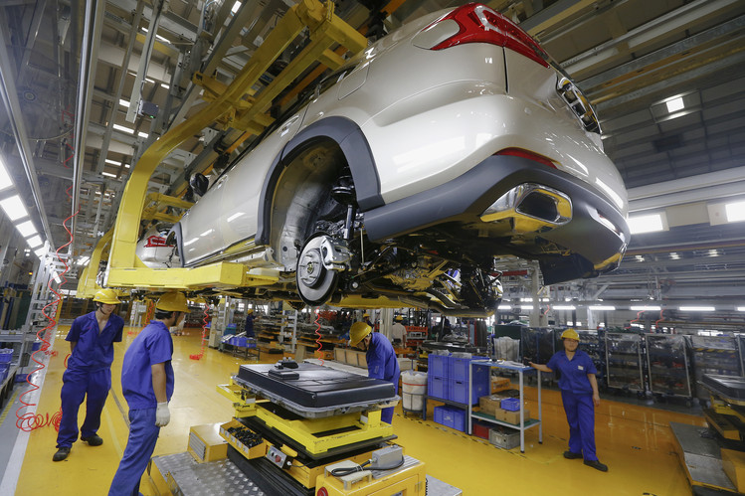
An electric-car battery about to be installed at a BYD assembly line in Shenzhen in 2016. PHOTO: BOBBY YIP/REUTERS
Already, Chinese-made models dominate. More than 100 electric models are on the domestic market. Sales of plug-in passenger vehicles reached 351,000 in 2016—nearly half the global total, according to EV-Volumes, a research group that tracks electric-car sales.
Chinese auto makers built nearly all those. Tesla Inc. is the only foreign electric-car maker to have sold in significant numbers, having imported and sold 11,000 cars last year.

New-energy mandate
Foreign makers will have to join the fray if they want to keep selling. Beijing on Thursday said it would require foreign auto companies manufacturing in China to start making new-energy vehicles in the country by 2019.
The nation’s overall car market is so huge, comprising one-third of 2016 global sales, according to Macquarie Research, that foreign auto makers have little choice but to adjust strategies to adapt.
“That’s why we’re investing so heavily in electrification,” General Motors Co. Chief Executive Mary Barra told reporters in Shanghai last month, when asked about China’s push to phase out traditional cars.
Of GM’s global unit sales, 40% were in China last year. Beijing’s bet has translated into “a very aggressive rollout on electrification in China,” said Ms. Barra, who detailed GM’s plans to have at least 10 plug-in models available in China by 2020. GM hasn’t outlined such targets in its other markets. GM currently has three plug-in models in China, including a local version of the Volt, introduced several months ago.
Foreign manufacturers were already making millions of gasoline cars in China annually, but they had held off building electric cars in the country until recently, and imports were discouraged by a 25% tariff. Bill Russo, a former Chrysler executive who is now managing director of auto consultancy Gao Fung Advisory Co. in Shanghai, said they had been reluctant to plunge into a market that didn’t yet offer significant scale.
Hints of scale are appearing. Sales of plug-in passenger cars in China have increased 40% this year, EV-Volumes said. They will make up 22% of Chinese auto purchases by 2025, projects Bernstein Research, up from 1% to 2% this year.
Growth EngineChina has surged past the U.S. in electric passenger car salesTHE WALL STREET JOURNALSources: China Association of Automobile Manufacturers; Inside EVs
ChinaU.S.World2011’12’13’14’15’160100,000200,000300,000400,000500,000600,000700,000800,000900,000
Volkswagen AG was firmly committed to diesel engines until it recently announced a sharp shift to embrace electric vehicles after its diesel-emissions scandal forced it to rethink strategy. China accounts for half its revenues, and VW Chief Executive Matthias Müller at last month’s Frankfurt auto show indicated China will help drive VW’s global transformation: “China and California are leading the way.”
Propelled by a China sales target of 1.5 million annual electric cars by 2025, VW will invest $83 billion rolling out 300 electric models world-wide by 2030, he said.
Some auto makers wonder if China’s electric-car demand growth will slow as the government dials back subsidies, as it has begun doing. “It’s the state’s support which is really driving the attention and demand for EVs,” Toyota Motor Corp.’s China head, Hiroji Onishi, told reporters at April’s Shanghai auto show, where Toyota said it would start building electric vehicles to fit Chinese requirements.
“I just have a slight skepticism that in the future, if these subsidies are gone,” Mr. Onishi said, “whether the consumers would still want to buy EVs at the market price.”
Still, global auto makers fear if they don’t build in China now they may lose out in other markets that move decisively toward electric cars, said Mr. Russo. “China,” he said, “will drive large-scale electrification of the global automotive industry.”
This year, Ford Motor Co. , the Renault-Nissan Alliance and Volkswagen have formed new Chinese joint ventures to build battery cars. Ford in a June statement pledged that 70% of its Chinese cars will be electric by 2025. Tesla said it is in talks to build a factory in Shanghai. In July, Mercedes-Benz parent Daimler AG said it would jointly invest $767 million to develop electric cars with state-run Beijing Automotive Industry Corp.

China began actively promoting electric cars in 2009 by introducing subsidies and setting sales targets. Sales began to take off in 2013. Electric vehicles took center stage in China’s industrial strategy with the 2015 launch of the Made in China 2025 plan, which calls for China to become a world leader in 10 future industries, including electric-vehicle production. China has provided $8 billion in subsidies so far.
France and the U.K. have set targets to ban gasoline-car sales by 2040. In Norway, among the world’s most advanced electric-vehicle markets, electric cars constitute nearly half of total vehicle sales.
The U.S. provides a federal tax credit of up to $7,500 to encourage electric-vehicle purchases and some states offer further incentives. California’s mandates for statewide reductions in greenhouse-gas emissions are tipping auto markets toward electric vehicles in the state.
China has gone a step beyond with its incentives. Authorities have guaranteed sales for Chinese makers, in part by buying vehicles for public fleets. Beijing’s municipal government has earmarked $1.3 billion to replace 70,000 city taxicabs with electric models.
China will have 4.8 million charging points by 2020, the government forecasts, up from 156,000 in March. The U.S. had 43,000 points in June, according to a University of Michigan study.
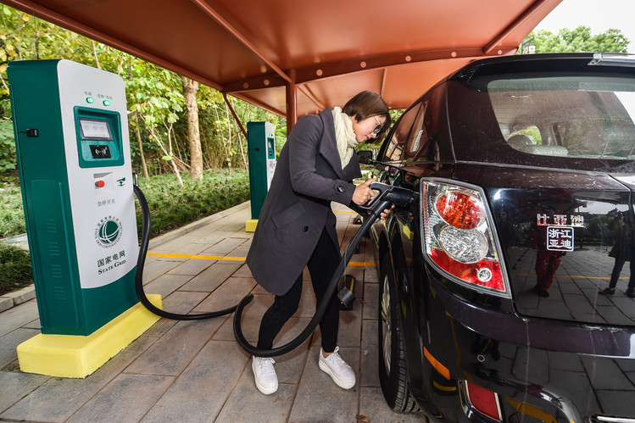
A driver charges an electric car in Huzhou City in 2016. PHOTO: XINHUA/ZUMA PRESS
At those rates, China has roughly one charging point for every six electric cars, versus about one for every 17 in the U.S. and Norway.

A persuasive tool
Beijing’s most persuasive tool—and a reason foreign makers are eager to start producing in China—is restricting license plates for new gasoline-powered cars in seven cities. In Beijing, more than 11 million people typically enter a monthly lottery for 14,000 gasoline-car plates. Shanghai auctions them to the highest bidders. Electric-vehicle buyers in the cities can get tags almost instantly at no cost.
Most Chinese auto makers have focused on building the most inexpensive electric cars they can. The best-selling Chinese model in the first half of 2017 was the Zhidou D2, retailing for under $7,000. At a Shanghai dealership of car maker Beijing Auto, manager Wang Yipeng said his top seller is the electric EV160 at roughly $11,000 with government subsidies—$22,000 without subsidies.

Electric Avenue

The best-selling pure-electric cars in China in the first half 0f 2017

*Those claimed by manufacturers †Retail prices after subsidies
Source: yiche.com; the manufacturers (ranges)
Many foreign makers, recognizing that the bulk of Chinese demand is at the low end, are producing entry-level cars. In July, GM launched its first pure-electric car for the Chinese market, the Baojun E100, with a $5,300 price tag. The Chevrolet Bolt, its premier U.S. electric model, isn’t available in China. Ford and Volkswagen have said their recently announced joint ventures will concentrate on entry-level electric cars.
Chinese auto makers are honing quality enough to improve their reputations in China, said Jeff Cai, general manager for auto product and quality at the China unit of JD Power, which rates autos by surveying consumers. “In the past two years, some Chinese manufacturers have made a breakthrough,” he said. Among Chinese consumers, “their perceived quality has taken a big jump.”
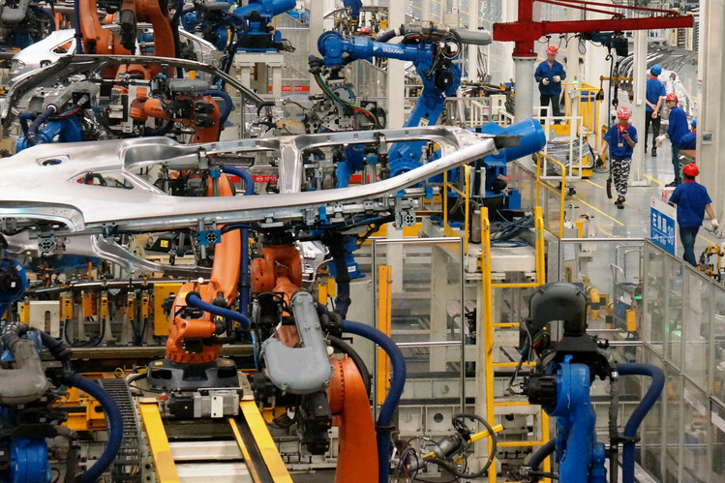
A BYD electric-car plant in Shenzhen. PHOTO: TREFOR MOSS/THE WALL STREET JOURNAL
BYD Co. , one of China’s big privately owned auto makers, hired Wolfgang Egger, formerly Audi Group’s head designer, to become its design chief last year. BYD has figured out the industrial part of the equation, Mr. Egger said, and now the challenge is overcoming a “Made in China” stigma—a commonly held view that foreign cars are superior. “The product can be excellent from a technical point of view,” he said, “but it needs a strong character.”
Cao Zhen, 35, wanted to buy a foreign gasoline car in April. “People feel that those brands are better quality, and that they make them look good,” he said. The Shanghai writer abandoned that idea because of the license-plate restrictions. Seeking a high-end Chinese-made electric vehicle, though, he struggled to find one expensive enough to fit his $45,000 budget.
He ended up spending $35,000 on a Roewe eRX5 plug-in made by state-run Shanghai Auto. It exceeded expectations, he said, and was a marked improvement on his previous car, a foreign make.
“In the next three years, the quality of Chinese EVs will improve a lot again,” said JD Power’s Mr. Cai. “Soon foreign [auto makers] could be the ones that struggle to compete.”
—Junya Qian, Mike Colias and Yoko Kubota contributed to this article.
Write to Trefor Moss at Trefor.Moss@wsj.com
Appeared in the October 3, 2017, print edition as 'China’s Leap In Electric Cars.

